26.43: a) The time constant
b) 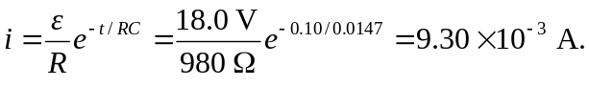
c) Once the switch is thrown, 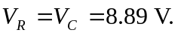
d)

